**KIDS-ZONE**

**Developer Guide**

|  |  |  |
| --- | --- | --- |
| **Supervisor:** | Miss Naureen Shamsher |  |
| **Batch:** | 2310b1 |  |
| **Group:** | … |  |
| **Serial no.** | **Enrollment number** | **Student Name** |
| 1. | Student1519924 | MUHAMMAD DANIYAL SIDDIQUI |
| 2. | Student1519925 | ABDUL MOIZ SIDDIQUI |
| 3. | Student1522820 | HAFIZ HUMAIR ADEEL |
| 4. | Student1519937 | MUHAMMAD AREEB |

KIDS-ZONE

**Home (Index.html)**

Welcome to KIDS=ZONE dynamic home page, your gateway to a about kids and information. Engage with Knowledge, Learning, Math’s Quiz etc. In our Website you can get all the accessories of kids Like Mathematics, Learning ABC and 123 with video. Our Website also also have Nursery Rhymes for Kids that can help Kids.

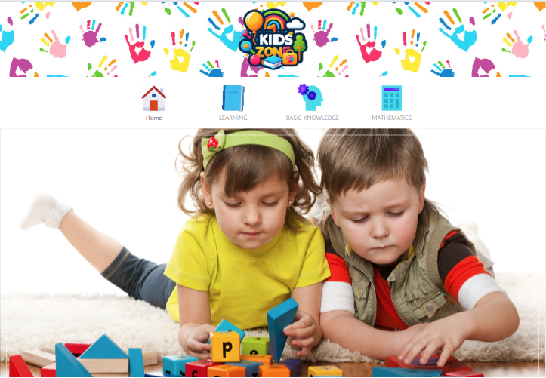

Figure 1: Home Page For Our Website:

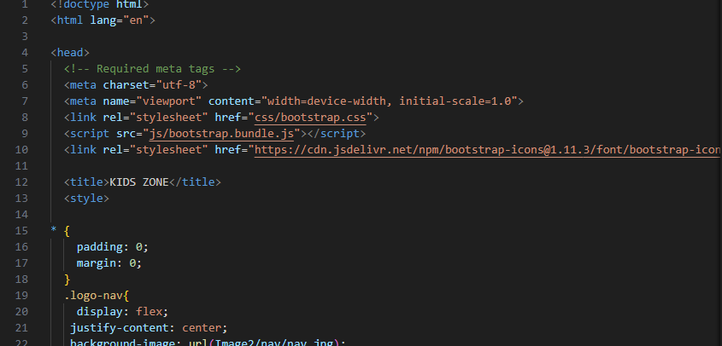

****Cards:

**Code Of Cards:**

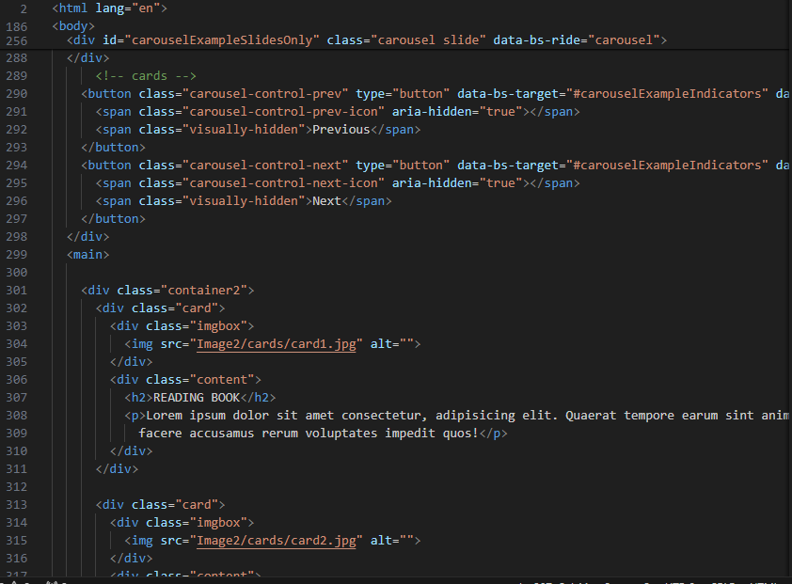

**Footer Section**

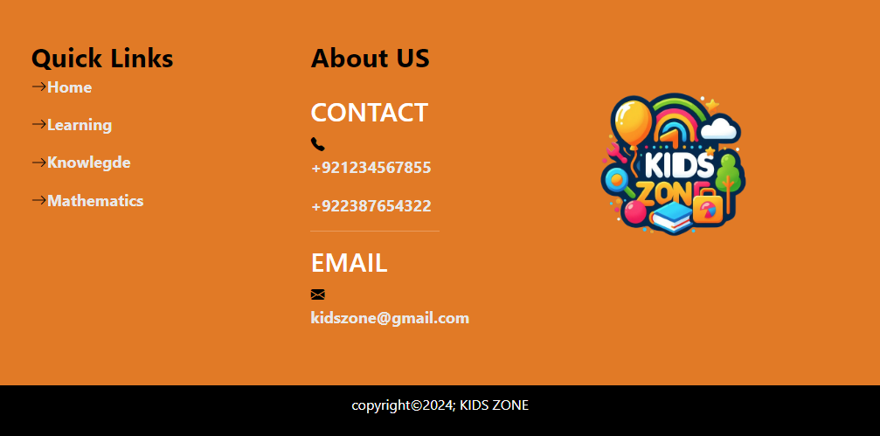

**Footer Code**

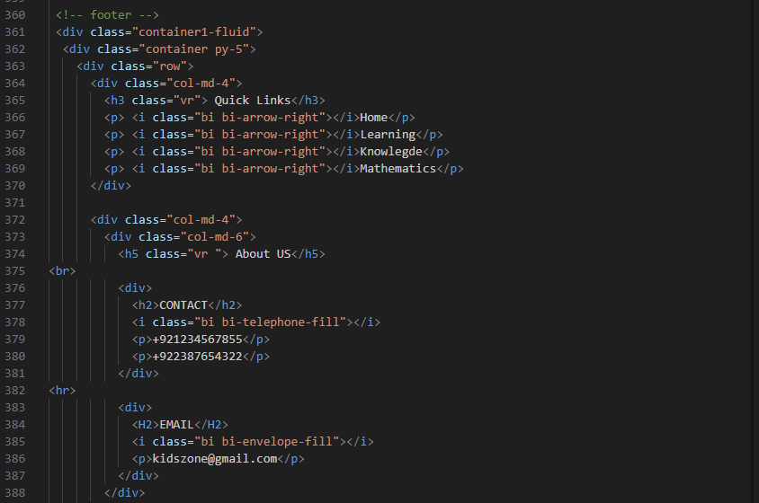

**Navbar**



**Navbar Code:**

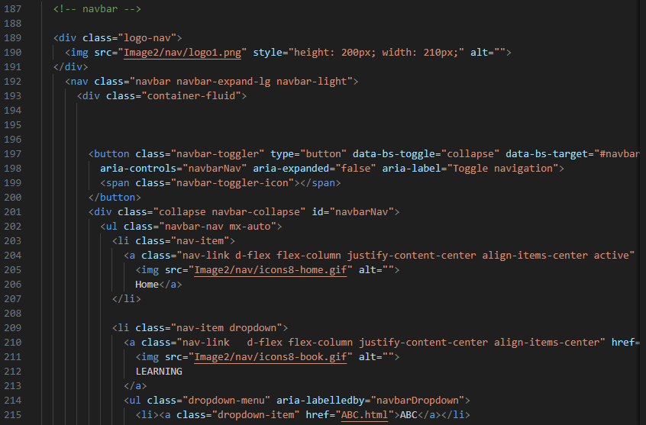

**Contact Page Code**

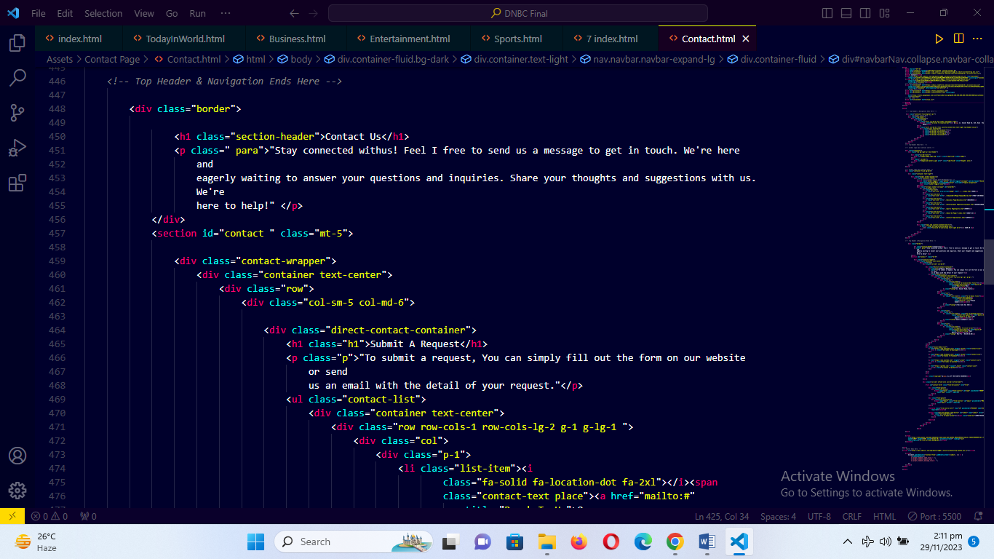

**Sign Up Page**

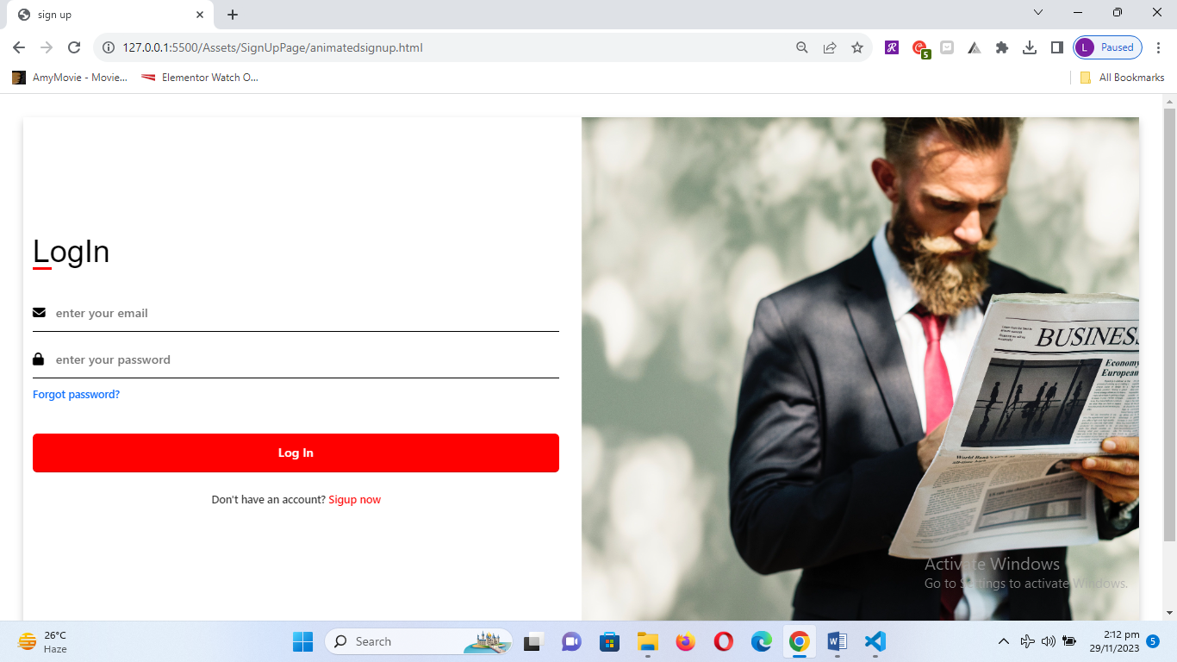

**Sign Up Code**

